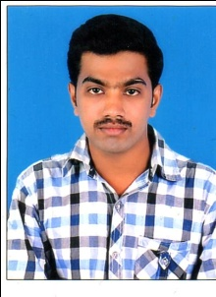
SELVAGANAPATHY . S
E-Mail: ganapathy0505@gmail.com
Mobile: +91 9497367822
SUMMARY
- Focused & goal driven with strong work ethics, continuously striving for improvement coupled with commitment to offer quality work.
- Adaptable & a quick learner with skills to work under pressure.
- Possesses strong negotiation, communication & analytical skills.

KNOWLEDGE PURVIEW
- M S office
- C & C++
WORK EXPERIENCE
June 2015 - March 2017 : lntelenet global service private limited
ROLE
- Digital banker – axis bank outbound sales process.

EDUCATION
- B.sc (Maths & Computer Application) from Govt college Munnar, Kerala,
(M.G University in 2012).
- 12th from S.K.A Higher Secondary school, chinnamannur ,Theni,
T.H.S.E Board in 2008 .
- 10th from S.K.A Higher Secondary school, chinnamannur ,Theni,
T.H.S.E Board in 2006 .

ACADEMIC PROJECTS
- B.sc (Mathematics & computer Applications) – Game theory.
PROFESSIONAL ATTRIBUTES:
- good decision-making skills.
- work as per requirements to the maximum of my ability.
- prefer to work in team & share ideas collectively.
- good communication skills.
- good motivating skills
HOBBIES
- playing and watching cricket
- listening songs

PERSONAL DETAILS
Date of Birth : 05 may 1991
Languages Known : English , Tamil & Malayalam
Address : Periavurai , Anamudi division,
Munnar , Idukki district,
Kerala - 685612
DECLARATION
I HEREBY DECLARE THAT THE ABOVE INFORMATION FURNISHED IS TRUE TO MY KNOWLEDGE.
DATE:
PLACE: HYDREABAD SELVAGANAPATHY . S

